Plan for Deployment:

Documentation:

1. https://devcenter.heroku.com/articles/deploying-spring-boot-apps-to-heroku

2. Specifying a Java version: [https://devcenter.heroku.com/articles/java-support#specifying-a-java-version](https://devcenter.heroku.com/articles/java-support" \l "specifying-a-java-version)

3. Video tutorial from 1 year ago explaining every step: https://www.youtube.com/watch?v=TixLbON3TR8

Steps to deploy

Before start, we need source code of the spring boot application and webpage. Also we need the database (sql file).

**1.** Add java version (17) in BookingApplication/src/main/resources/applicationproperties.

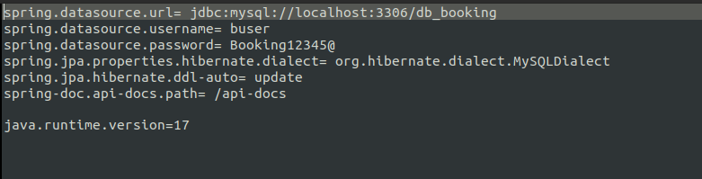

Username and password are gonna be changed in the next steps.

Map with the steps:

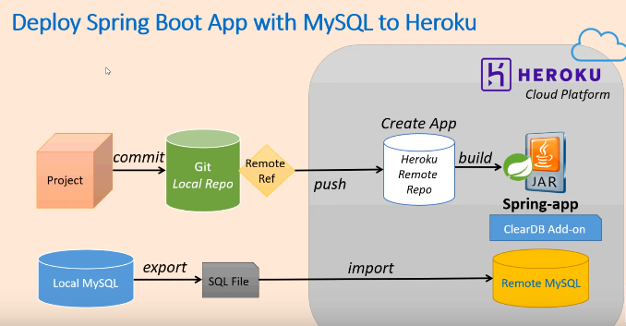

**2.** Create a Heroku account and verified it (enter payment card info). Then download and install Heroku Client. The following link https://devcenter.heroku.com/articles/deploying-spring-boot- apps-to-heroku provide the button to download it automatically:

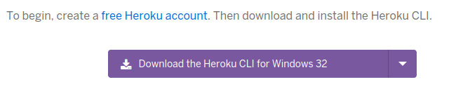

Also, install Git (download from --> https://git-scm.com/downloads)

**3.** Initialize Local Git repo:

Change the current folder to where you have the application in your local. Then, when you are in the folder from the repository, execute the followings commands:

a. git init.

b. git add .

c. git commit -m “first deployment”

d. git remote -v

e. heroku login (a windows on the browser will be open, click on login button). Then, you are logged in the system.

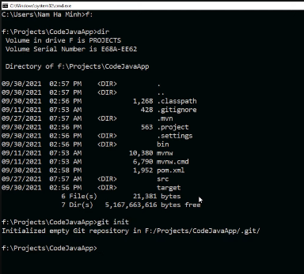

**4.** Create new heroku app

Execute the followings commands:

a. heroku create (if you don’t specify the name, it will choose a random name)

b. git remote -v

**5.** Deploy Spring boot project to heroku

Execute the followings commands:

a. git push heroku master (building the project).

b. heroku apps (verify the data for the applicacion deployed on heroku)

If there are errors, execute the command *heroku logs –tail*

c. heroku open (open the application on the browser) <- this step can fail, because there is no database in Heroku. En el proximo paso vemos como agregar la base de datos.

Webpage is in the folder BookingApplication/src/main/resources/templates/ (inside of the application). Maybe you want to deploy the webpage separately and point the links to the Spring Boot application. For example:

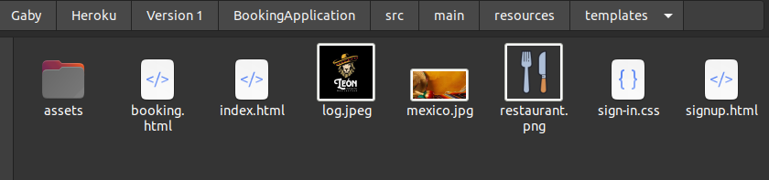

Index.html

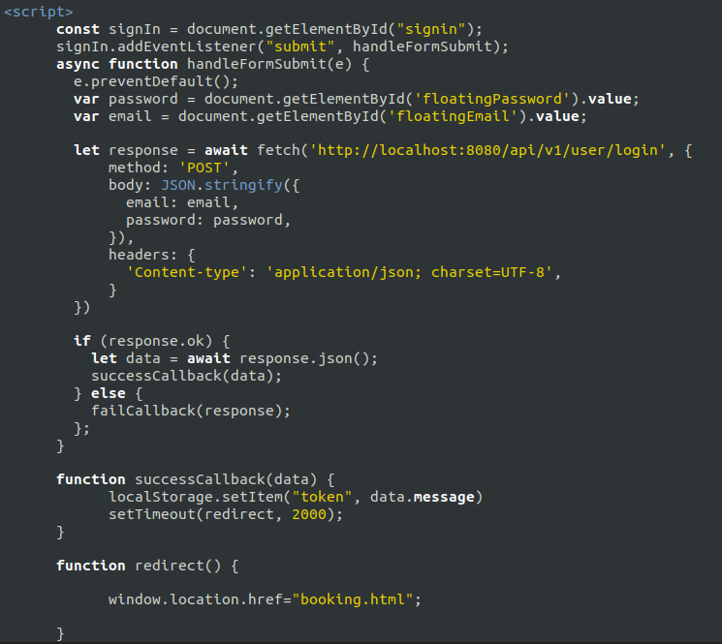

Localhost:8080 has to be replaced by ip:port where ip is where the Spring boot application is deployed and port is the port number where the application is listening.

Once the database is deployed (it will be explained in the next step), we can test the application using postman. When we type heroku open, a tab is open on the browser. We copy the url and we use postman to test the application.

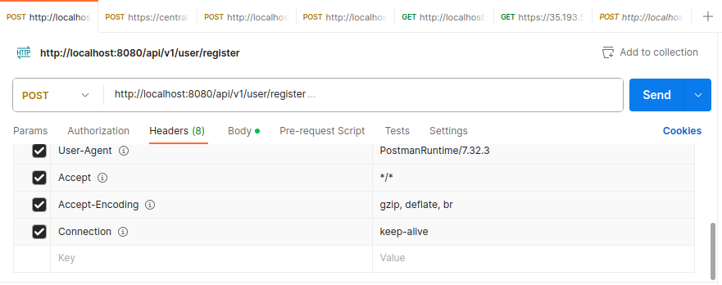

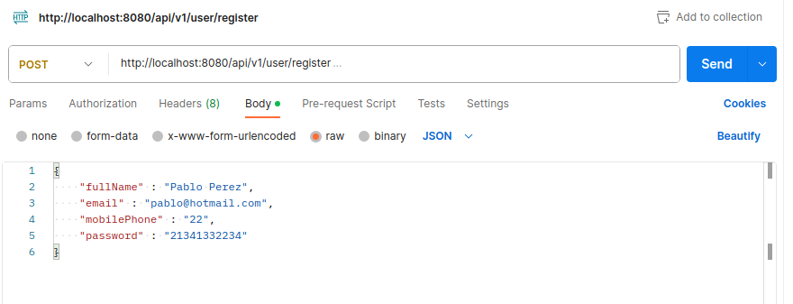

**6.** Add database mysql to Heroku

Execute the following commandas:

a. In the previous step, the command heroku open throws an error because we don’t have database on heroku

b. to see errors heroku logs and we can see the error

**7.** Install Mysql add-on

From here, follow the video and copy the commands on the final document to be sent to the lecturer (Minute -> 12:29)